### Python

Python enables programs to be written compactly and readably. Programs written in Python are typically much shorter than equivalent C, C++, or Java programs, for several reasons:

* the high-level data types allow you to express complex operations in a single statement;
* statement grouping is done by indentation instead of beginning and ending brackets;
* no variable or argument declarations are necessary.

Python is extensible.It is a scripting language.

Basic Arithmetic In Python

num1=3

num2=10

answer=num1/num2

print(answer)

Output => 0.3

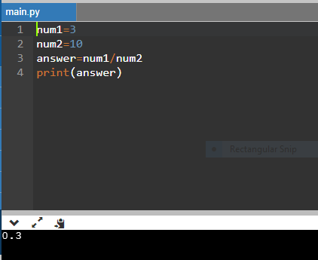

answer = num1 *num2

print(answer)

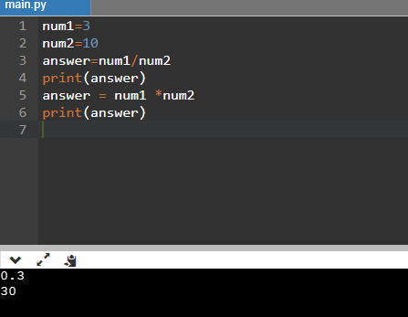

Modulus operator (%) gives the remainder of an operation.

answer=num2%num1

print(answer)

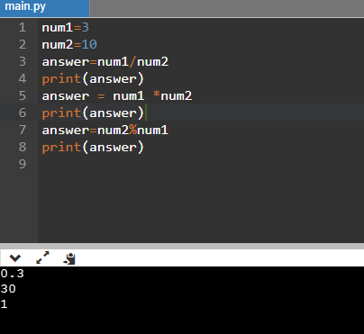

### READING DATA & PRINTING THE SAME

s=input('My name is ')

print('Your name is '+s)

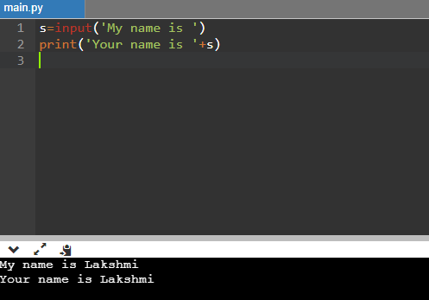

To convert characters into lower case we use lower() method.

Eg :- print(s.lower())

To find the length of a string we use the len() method.

Eg:- print(s.len())

**Example 1**

age=int(input())

if(age >=18):

print('Adult')

else:

print('MInor')

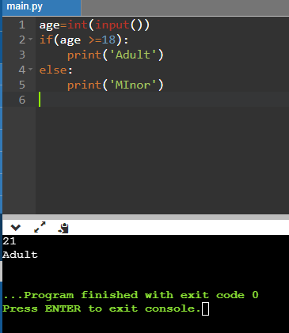

**Example 2**

def greetings():

s=input()

print("Hi "+s+" Good evening")

greetings()

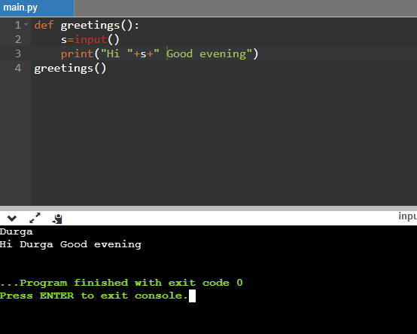

**Example 3**

word = 'Python'

print(word[0]) # character in position 0

print(word[5]) # character in position 5

print(word[-1]) # last character

print(word[-2]) # second-last character

print(word[0:2]) # characters from position 0 (included) to 2 (excluded)

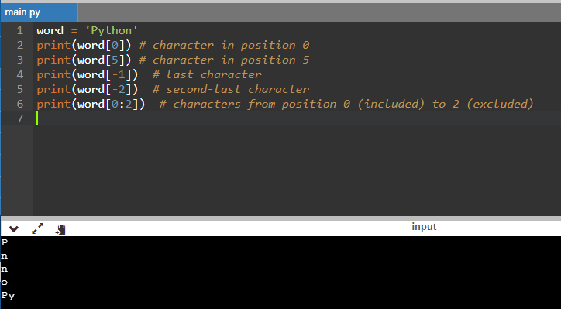

Python also provides some built-in data types such as dict, [list](https://docs.python.org/ko/3.6/library/stdtypes.html#list), [set](https://docs.python.org/ko/3.6/library/stdtypes.html#set) and [frozenset](https://docs.python.org/ko/3.6/library/stdtypes.html#frozenset), and tuple. The str class is used to hold Unicode strings, and the [bytes](https://docs.python.org/ko/3.6/library/stdtypes.html#bytes) class is used to hold binary data.

### LISTS

### Python knows a number of compound data types, used to group together other values. The most versatile is the *list*, which can be written as a list of comma-separated values between square brackets. Lists might contain items of different types, but usually the items all have the same type.

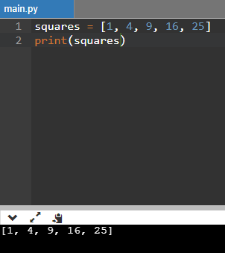

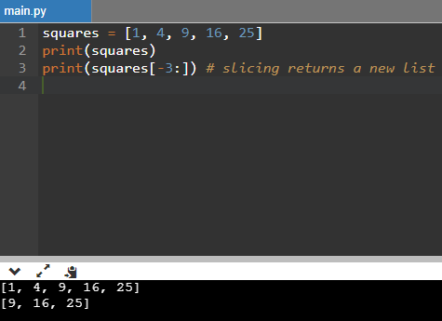

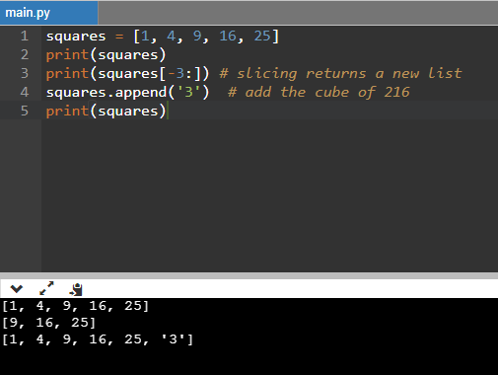

### DICTIONARIES

Dictionaries are used to store data values in key:value pairs. They are ordered, changeable, and do not allow duplicates.

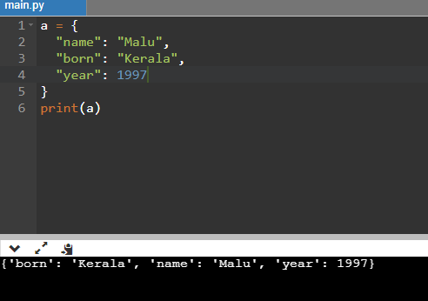

### TUPLES

Tuple is one of 4 built-in data types in Python used to store collections of data, apart from List, Set, and Dictionary, all with different qualities and usage.A tuple is a collection which is ordered, allows duplicates and unchangeable. Tuples are written with round brackets.

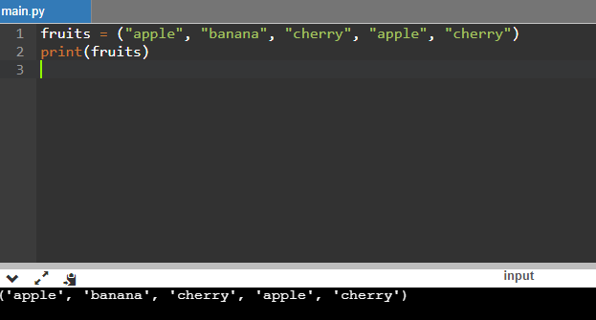

### SETS

A set is an unordered collection with no duplicate elements. It eliminates duplicate entries. Set objects also support mathematical operations like union, intersection, difference, and symmetric difference. Curly braces or the [set()](https://docs.python.org/3/library/stdtypes.html#set) function can be used to create sets.

